**ASSIGNMENT-04**

**Problem Statement :- SMS SPAM Classification**

|  |  |
| --- | --- |
| **Assignment Date** | 5 October 2022 |
| **Student Name** | Bhuvaneshwari M |
| **Student Roll Number** | 113219071004 |
| **Maximum Marks** | 2 Marks |

QUESTION 1:

Download the Dataset

Dataset is downloaded and uploaded

QUESTION 2:

Import required library

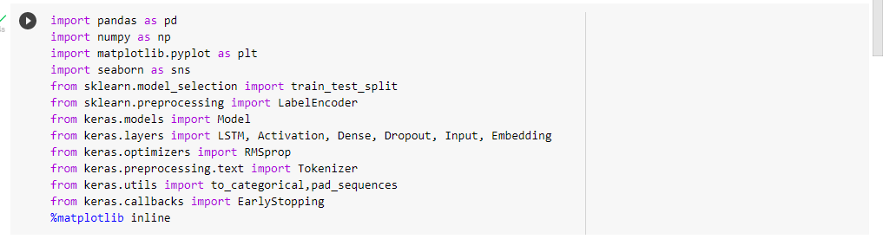

QUESTION 3:

Read dataset and do pre-processing

df = pd.read_csv('/content/drive/MyDrive/spam.csv/archive (1).zip',delimiter=',',encoding='latin-1')

df.head()

df.drop(['Unnamed: 2', 'Unnamed: 3', 'Unnamed: 4'],axis=1,inplace=True)

df.info()

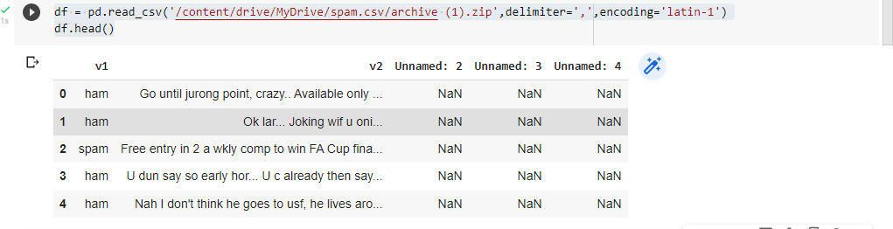

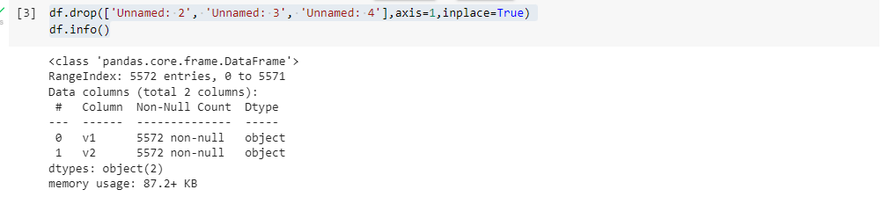

QUESTION 4:

Create model

sns.countplot(df.v1)

plt.xlabel('Label')

plt.title('Number of ham and spam messages')

X = df.v2

Y = df.v1

le = LabelEncoder()

Y = le.fit_transform(Y)

Y = Y.reshape(-1,1)

X_train,X_test,Y_train,Y_test = train_test_split(X,Y,test_size=0.15)

max_words = 1000

max_len = 150

tok = Tokenizer(num_words=max_words)

tok.fit_on_texts(X_train)

sequences = tok.texts_to_sequences(X_train)

sequences_matrix =pad_sequences(sequences,maxlen=max_len)

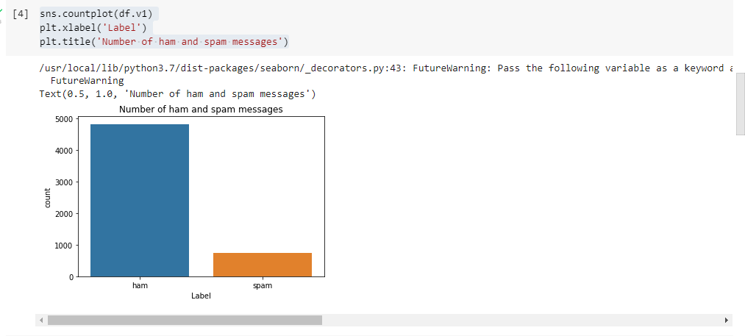

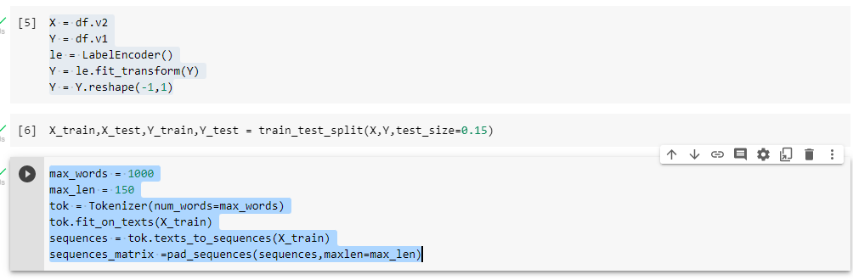

QUESTION 5:

Add Layers (LSTM, Dense-(Hidden Layers), Output)

def RNN():

inputs = Input(name='inputs',shape=[max_len])

layer = Embedding(max_words,50,input_length=max_len)(inputs)

layer = LSTM(64)(layer)

layer = Dense(256,name='FC1')(layer)

layer = Activation('relu')(layer)

layer = Dropout(0.5)(layer)

layer = Dense(1,name='out_layer')(layer)

layer = Activation('sigmoid')(layer)

model = Model(inputs=inputs,outputs=layer)

return model

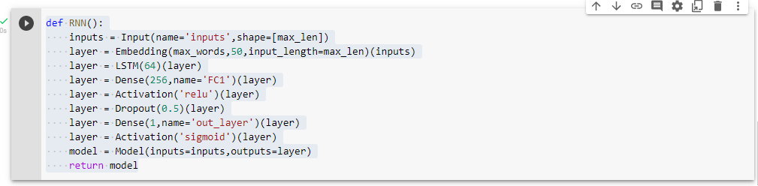

QUESTION 6:

Compile the Model

model = RNN()

model.summary()

model.compile(loss='binary_crossentropy',optimizer=RMSprop(),metrics=['accuracy'])

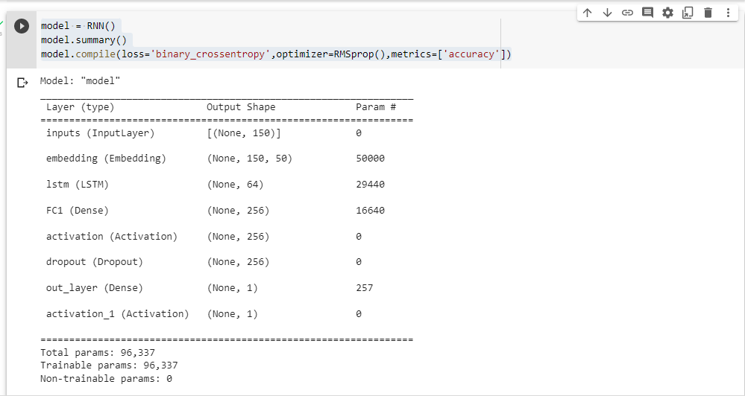

QUESTION 7:

Fit the Model

model.fit(sequences_matrix,Y_train,batch_size=128,epochs=10,

validation_split=0.2,callbacks=[EarlyStopping(monitor='val_loss',min_delta=0.0001)])

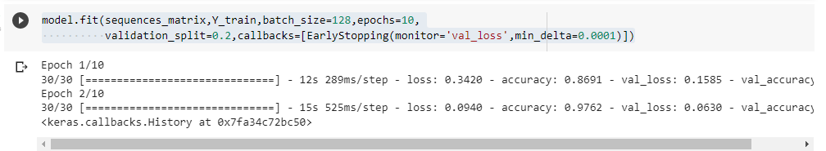

QUESTION 8:

Test The Model

test_sequences = tok.texts_to_sequences(X_test)

test_sequences_matrix =pad_sequences(test_sequences,maxlen=max_len)

accr = model.evaluate(test_sequences_matrix,Y_test)

print('Test set\n Loss: {:0.3f}\n Accuracy: {:0.3f}'.format(accr[0],accr[1]))

